HTML Entities

📘 Definition
# Source: AI Source: Provided by: [Data Path: Persons Table -> ID Column: 1, Name_En Column: Motasem Essam] -> From: [ChatGPT] on [5/6/2026]
HTML entities are special codes used to display:
- reserved HTML characters
- symbols
- emojis
- special characters
Entities start with:
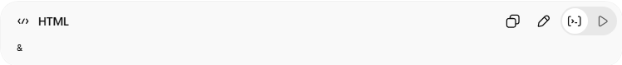
&
and end with:
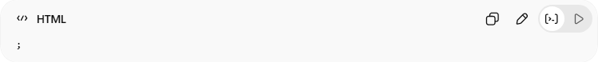
;

🧠 Why Use HTML Entities?
# Source: AI Source: Provided by: [Data Path: Persons Table -> ID Column: 1, Name_En Column: Motasem Essam] -> From: [ChatGPT] on [5/6/2026]
Some characters are reserved in HTML and cannot be written directly.
Example:
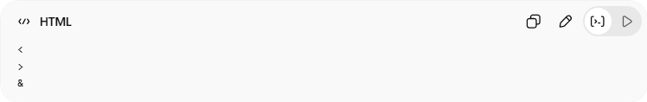
<
>
&
Without entities, the browser may interpret them as HTML code.

🧩 Common HTML Entities
# Source: AI Source: Provided by: [Data Path: Persons Table -> ID Column: 1, Name_En Column: Motasem Essam] -> From: [ChatGPT] on [5/6/2026]
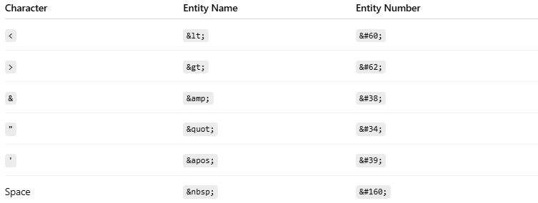
Character | Entity Name | Entity Number
< | &lt; | &#60;
> | &gt; | &#62;
& | &amp; | &#38;
" | &quot; | &#34;
' | &apos; | &#39;
Space | &nbsp; | &#160;

1. 🔹 Less Than <
# Source: AI Source: Provided by: [Data Path: Persons Table -> ID Column: 1, Name_En Column: Motasem Essam] -> From: [ChatGPT] on [5/6/2026]
📖 Description
Displays the < character.
💻 Example:
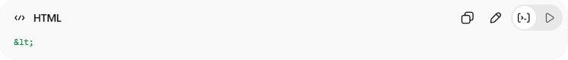
&lt;
👉 Output:
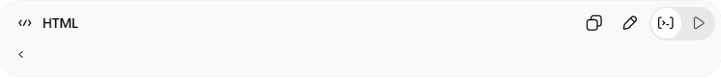
<

2. 🔹 Greater Than >
# Source: AI Source: Provided by: [Data Path: Persons Table -> ID Column: 1, Name_En Column: Motasem Essam] -> From: [ChatGPT] on [5/6/2026]
💻 Example:
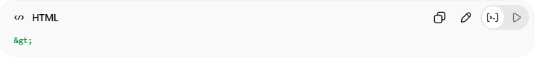
&gt;
👉 Output:
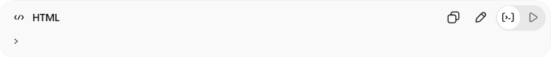
>

3. 🔹 Ampersand &
# Source: AI Source: Provided by: [Data Path: Persons Table -> ID Column: 1, Name_En Column: Motasem Essam] -> From: [ChatGPT] on [5/6/2026]
💻 Example:
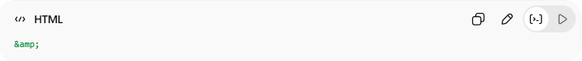
&amp;
👉 Output:
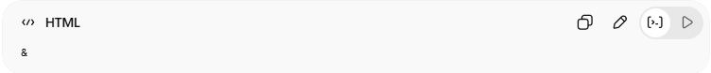
&

4. 🔹 Double Quotes "
# Source: AI Source: Provided by: [Data Path: Persons Table -> ID Column: 1, Name_En Column: Motasem Essam] -> From: [ChatGPT] on [5/6/2026]
💻 Example:
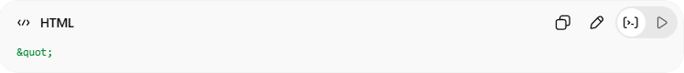
&quot;
👉 Output:
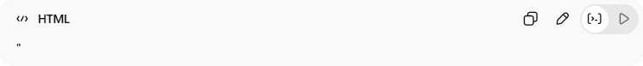
"

5. 🔹 Apostrophe '
# Source: AI Source: Provided by: [Data Path: Persons Table -> ID Column: 1, Name_En Column: Motasem Essam] -> From: [ChatGPT] on [5/6/2026]
💻 Example:
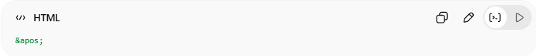
&apos;
👉 Output:
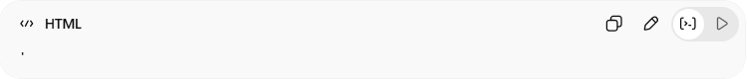
'

6. 🔹 Non-Breaking Space
# Source: AI Source: Provided by: [Data Path: Persons Table -> ID Column: 1, Name_En Column: Motasem Essam] -> From: [ChatGPT] on [5/6/2026]
📖 Description
Adds extra spaces that do not collapse.
💻 Example:
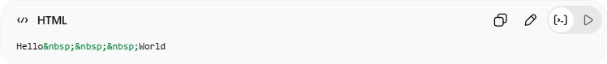
Hello&nbsp;&nbsp;&nbsp;World
👉 Output:
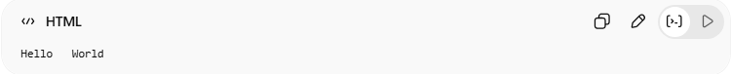
Hello World

🌍 Common Symbol Entities
# Source: AI Source: Provided by: [Data Path: Persons Table -> ID Column: 1, Name_En Column: Motasem Essam] -> From: [ChatGPT] on [5/6/2026]
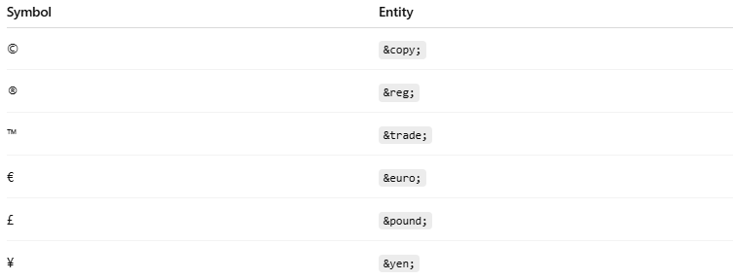
Symbol | Entity
© | &copy;
® | &reg;
™ | &trade;
€ | &euro;
£ | &pound;
¥ | &yen;

💻 Example:
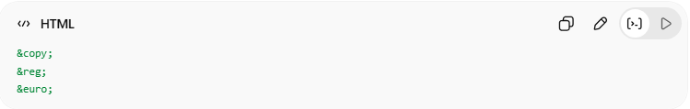
&copy;
&reg;
&euro;

😀 HTML Emoji Entities
# Source: AI Source: Provided by: [Data Path: Persons Table -> ID Column: 1, Name_En Column: Motasem Essam] -> From: [ChatGPT] on [5/6/2026]
📖 Description
HTML supports emojis using Unicode.
💻 Example:
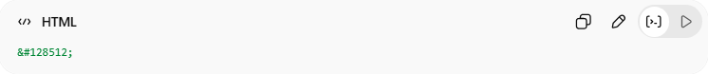
&#128512;
👉 😀 Emoji

🧮 Entity Types
# Source: AI Source: Provided by: [Data Path: Persons Table -> ID Column: 1, Name_En Column: Motasem Essam] -> From: [ChatGPT] on [5/6/2026]
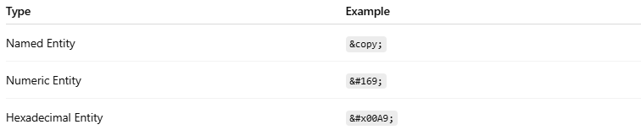
Type | Example
Named Entity | &copy;
Numeric Entity | &#169;
Hexadecimal Entity | &#x00A9;
💻 Example:
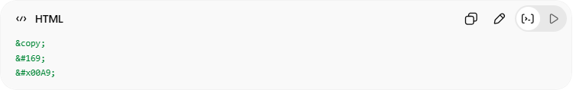
&copy;
&#169;
&#x00A9;
👉 All display:
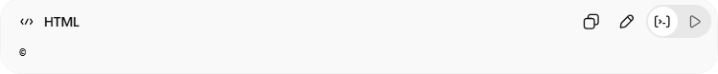
©

💻 Example

Full Example
# Source: AI Source: Provided by: [Data Path: Persons Table -> ID Column: 1, Name_En Column: Motasem Essam] -> From: [ChatGPT] on [5/6/2026]
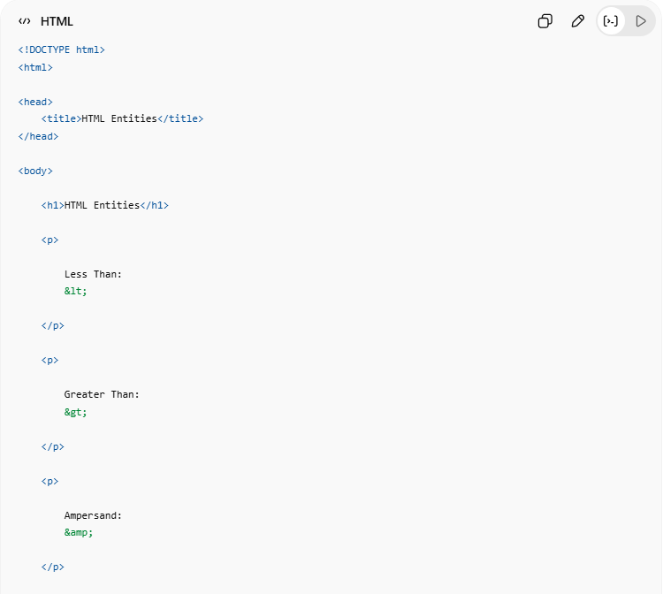
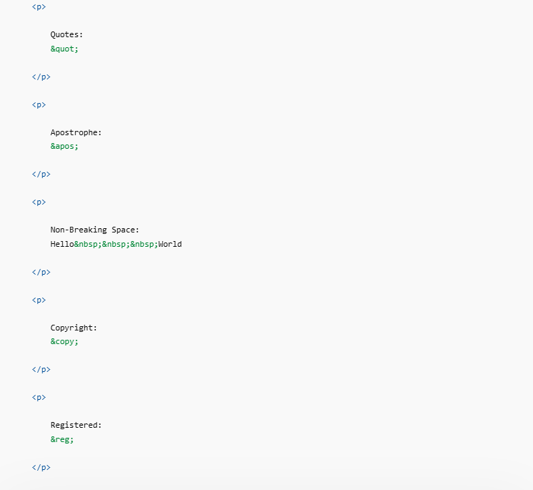
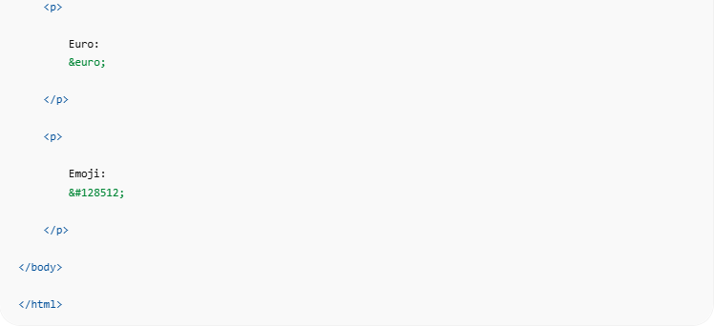
<!DOCTYPE html>
<html>
<head>
<title>HTML Entities</title>
</head>
<body>
<h1>HTML Entities</h1>
<p>
Less Than:
&lt;
</p>
<p>
Greater Than:
&gt;
</p>
<p>
Ampersand:
&amp;
</p>
<p>
Quotes:
&quot;
</p>
<p>
Apostrophe:
&apos;
</p>
<p>
Non-Breaking Space:
Hello&nbsp;&nbsp;&nbsp;World
</p>
<p>
Copyright:
&copy;
</p>
<p>
Registered:
&reg;
</p>
<p>
Euro:
&euro;
</p>
<p>
Emoji:
&#128512;
</p>
</body>
</html>

Real Example
# Source: ScreenShot Source: Provided by: [Persons Table -> ID Column: 1, Name_En Column: Motasem Essam] -> Tool: [Automation Table -> ID Column: 16, Name_En Column: Screen Capture] -> From [Operating System: Windows] on [5/6/2026]
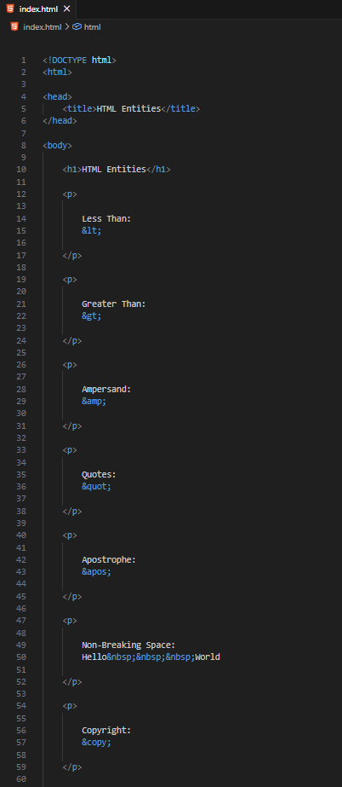
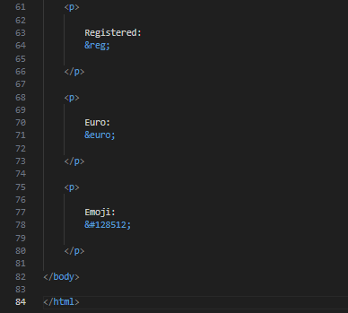
<!DOCTYPE html>
<html>

<head>
<title>HTML Entities</title>
</head>

<body>

<h1>HTML Entities</h1>

<p>

Less Than:
&lt;

</p>

<p>

Greater Than:
&gt;

</p>

<p>

Ampersand:
&amp;

</p>

<p>

Quotes:
&quot;

</p>

<p>

Apostrophe:
&apos;

</p>

<p>

Non-Breaking Space:
Hello&nbsp;&nbsp;&nbsp;World

</p>

<p>

Copyright:
&copy;

</p>

<p>

Registered:
&reg;

</p>

<p>

Euro:
&euro;

</p>

<p>

Emoji:
&#128512;

</p>

</body>

</html>
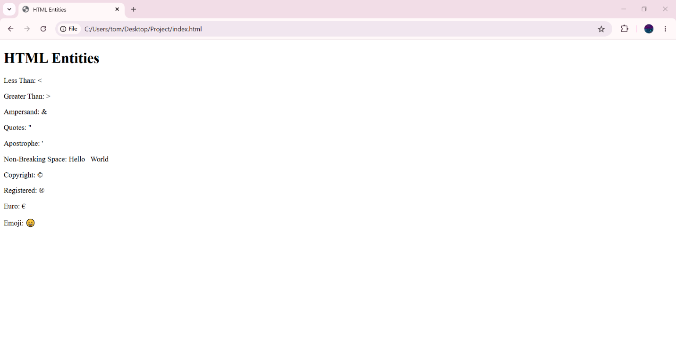

🧪 What You Can Test
# Source: AI Source: Provided by: [Data Path: Persons Table -> ID Column: 1, Name_En Column: Motasem Essam] -> From: [ChatGPT] on [5/6/2026]
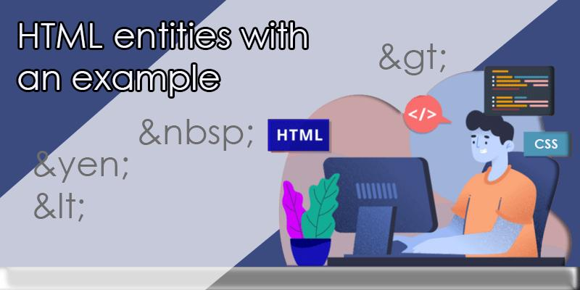
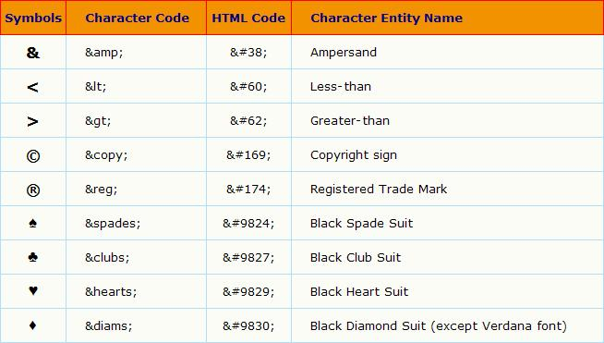
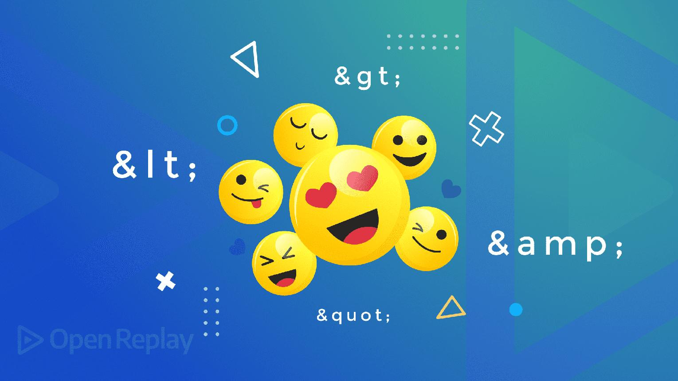
Entity | Output
&lt; | <
&gt; | >
&amp; | &
&copy; | ©
&#128512; | 😀

⚠️ Important Notes

✅ Use entities for reserved characters
# Source: AI Source: Provided by: [Data Path: Persons Table -> ID Column: 1, Name_En Column: Motasem Essam] -> From: [ChatGPT] on [5/6/2026]
👉 Prevent HTML parsing issues

✅ &nbsp; prevents space collapsing
# Source: AI Source: Provided by: [Data Path: Persons Table -> ID Column: 1, Name_En Column: Motasem Essam] -> From: [ChatGPT] on [5/6/2026]
👉 Useful for formatting

✅ Unicode entities support emojis
# Source: AI Source: Provided by: [Data Path: Persons Table -> ID Column: 1, Name_En Column: Motasem Essam] -> From: [ChatGPT] on [5/6/2026]
👉 Modern browsers support many emojis

❌ Avoid excessive &nbsp; for layout
# Source: AI Source: Provided by: [Data Path: Persons Table -> ID Column: 1, Name_En Column: Motasem Essam] -> From: [ChatGPT] on [5/6/2026]
👉 Use CSS spacing instead

🚀 In short:
# Source: AI Source: Provided by: [Data Path: Persons Table -> ID Column: 1, Name_En Column: Motasem Essam] -> From: [ChatGPT] on [5/6/2026]
HTML entities are special codes used to display reserved characters, symbols, spaces, and emojis safely inside webpages.

